CA2 Website Report

Video Game selling Website

X00129654: Jake Walsh

X00130180: Jordan Williams

X00131110: Declan Thomas

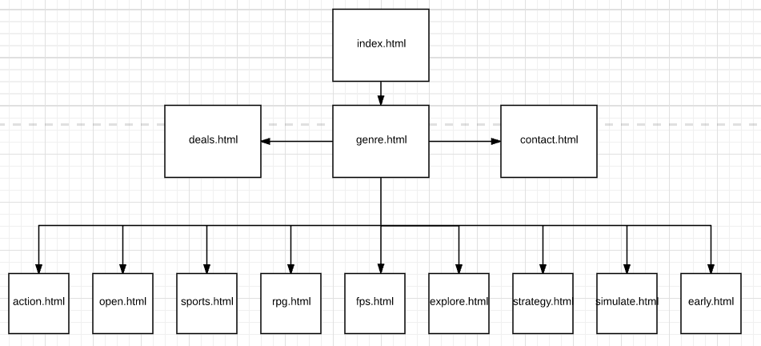

Part 1a: Site Structure and Navigation

We decided to create a website based around buying video games. We looked at sites like Amazon and Gamestop as a template for what our site should be like. We expect our users to be between the ages of 13-30 as these are the ages most commonly associated with playing video games. Aswell as the users being able to access our site, we will also be able to modify the site to add games to it. We created a forms.html page to allow us to do this. We ensured that our site is easy to navigate and find what you are looking for. We ensured that there was little clutter on any of the pages and that the colours on our site were not straining on the eyes. We decided on having 4 main pages(including home page) that can be accessed immediately as you open our site. Every page has a navigation bar at the top and bottom to ensure that the user has as much freedom as the like whilst navigating through the site. Within our genres.html page we have 9 more pages that contain games of each genre specified. This gives the user a clear direction to where they will need to go if they are looking for a certain game from a particular genre. We felt that consistency would be key for our website to function fluidly and effectively. Therefore, all genre pages follow the same layout with minor changes on each page. This layout is also the same on the index.html and deals.html pages. We also gave the user an option of contacting us if they have any queries or issues regarding their purchases. As such we created a simple Contact.html page to facilitate this. As seen above in our hierarchical chart, all pages are interlinked allowing for easy navigation through the site. All connections between pages have been clearly defined and made easy to follow by our site layout. We accomplished through the use of buttons. We also ensured that the home page can be accessed on any page within the site allowing for a quick transition back to the start.

Page Design

With regards to our page layout, we decided that simplicity was key to allowing the user to see the most important things on our site such as links to games, prices of games, latest deals etc. We decided on a fairly rigid layout as a result with each game being designated a block on the page where an image and some text along with a button to buy the game populated each block. The only pages that don’t have this precise layout are the genre.html and contact.html pages as they simply display more presentable with a different layout. As far as the colour scheme is concerned we wanted something that didn’t strain the eyes and look out of place. We settled on a violet colour for the background and simple black text everywhere else. We also ensured that the buttons on the pages were bright and stood out so that the user could easily see where to purchase items. The price of each item also displays on the buttons. As for as images are concerned, we decided that we would use the cover of each game as a way of highlighting its location on the site. This is what the user would come to expect as they would firstly notice the image of the game they are looking for, before they would notice the title of it on the page. As a result of using Twitter Bootstrap our site is also responsive and looks very presentable on all devices. We also created our own logo which displays as a favicon at the top of all of our webpages. This logo can also be found on the contact.html page. We felt it was important to have a logo which displayed on the site. All three group members were involved in the creation of the site with the work being dispersed equally amongst us. We planned our site as a group and came up with the hierarchical chart before we began coding. Jake Walsh(x00129654) began by selecting the appropriate bootstrap html and CSS that aided the creation of our site. Once we had a template in place for each page we worked on the home page as a group ensuring that this page was perfect as it would serve as the template for the other pages. Once our home page was finished we had 12 other pages to created, so we split the workload evenly with each person designing 4 pages. Once all of the pages were created we linked them together to complete the website. We also went on to design 3 forms pages. Two of these pages(form and category) will be accessible only by the administrator whilst the other checkout page will be available for all users. These forms pages can be accessed by changing the URL to directly access each page. For example to access the add form you must search **localhost:9000/form**. The other pages can be accessed similarly by searching **localhost:9000/checkout** and **localhost:9000/category** respectively.